附件2 翁源县新增历史遗留矿山图斑遥感影像图

1、WS4402291002260001图斑号切图
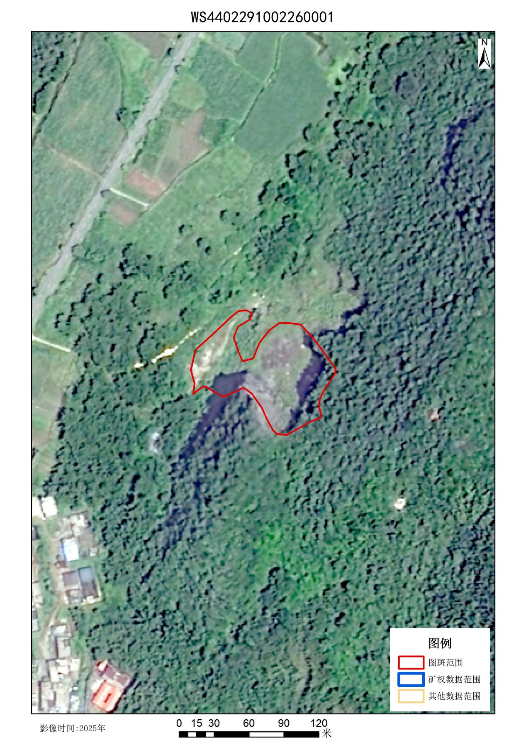
- YZ4402291042050001图斑号切图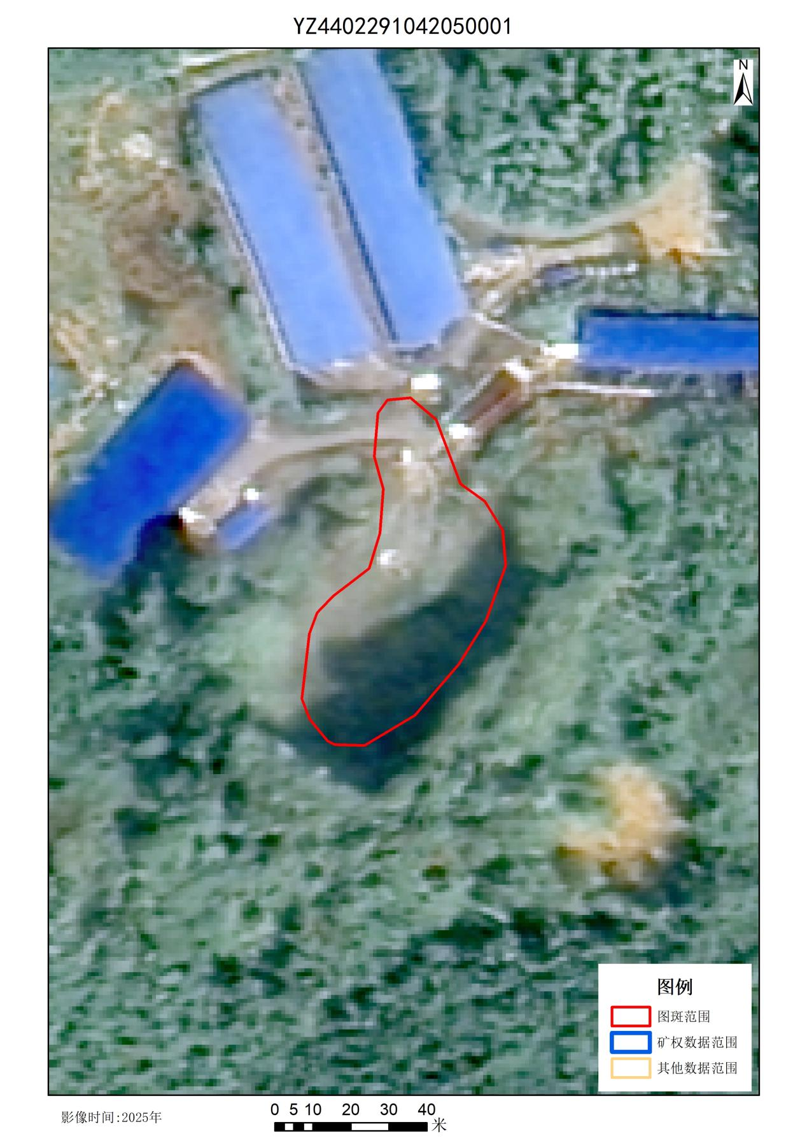

- WS4402291002260020图斑号切图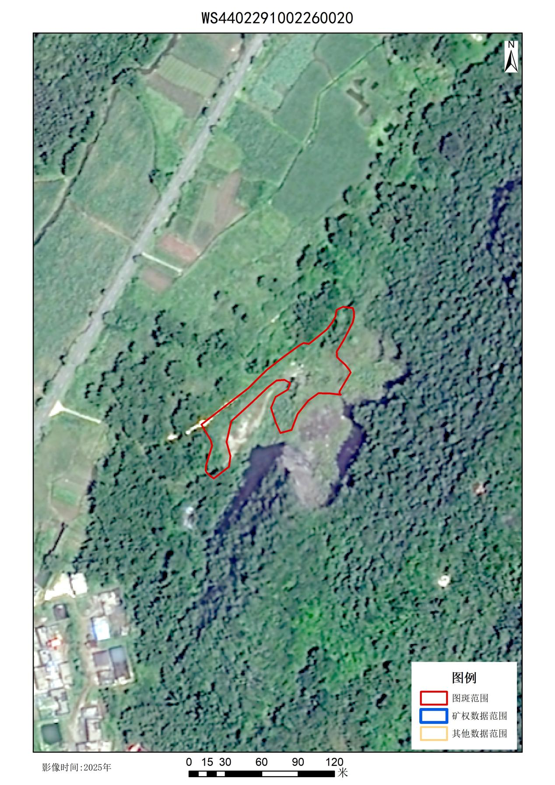

- YZ4402291112180005图斑号切图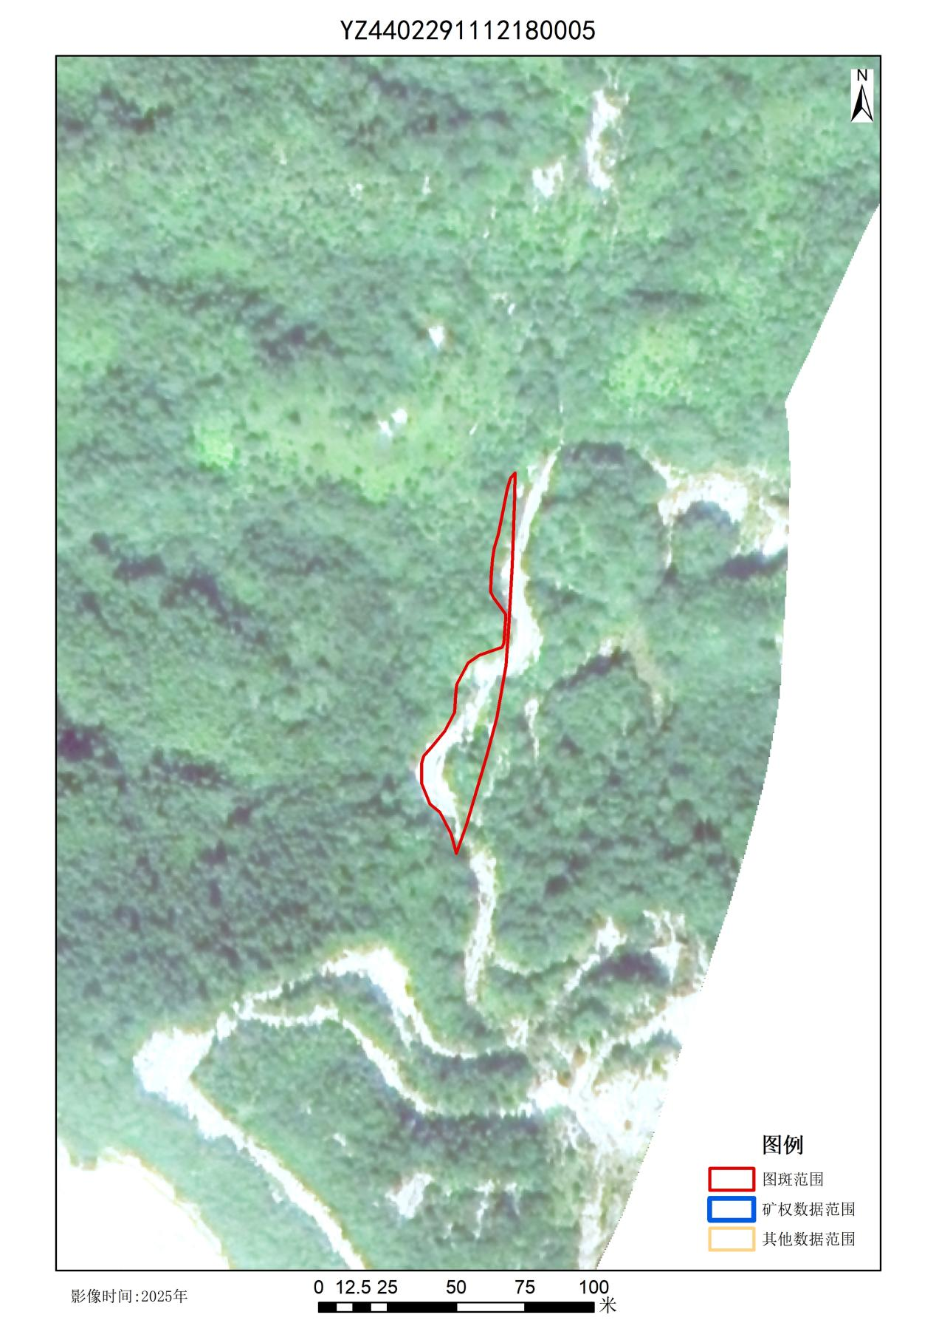

- WS4402291112180006图斑号切图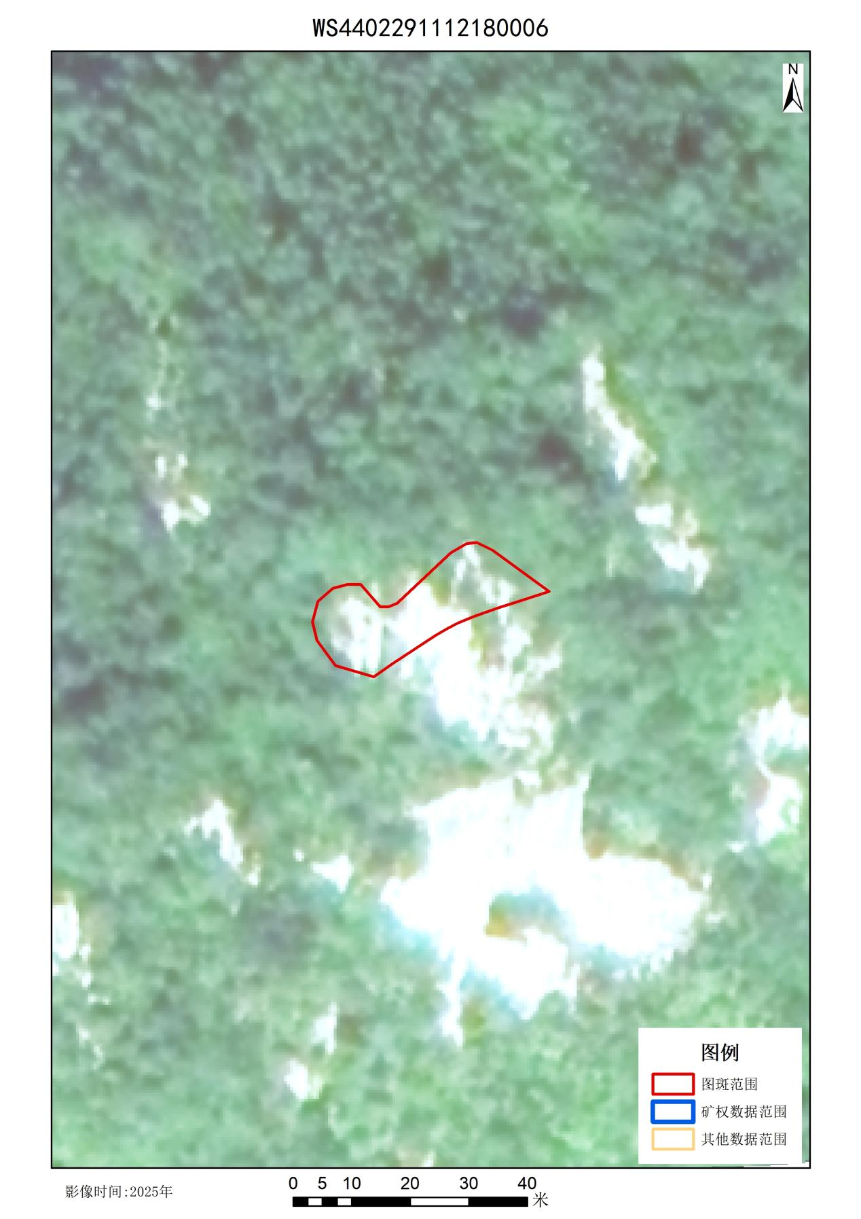

- WS4402291042010005图斑号切图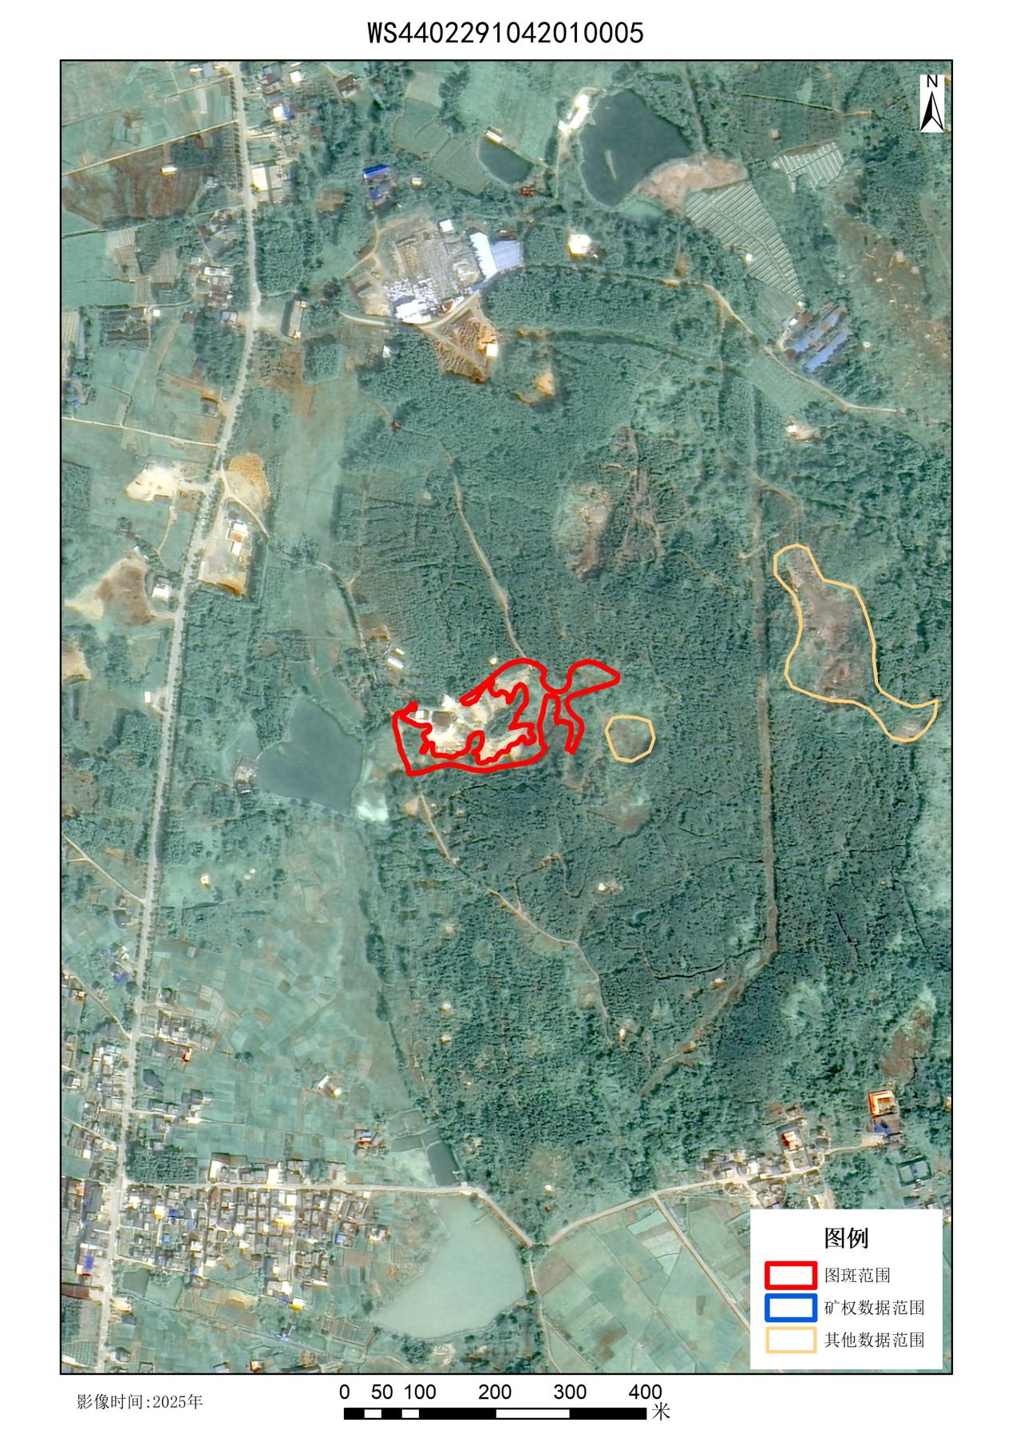

- WS4402291042210001图斑号切图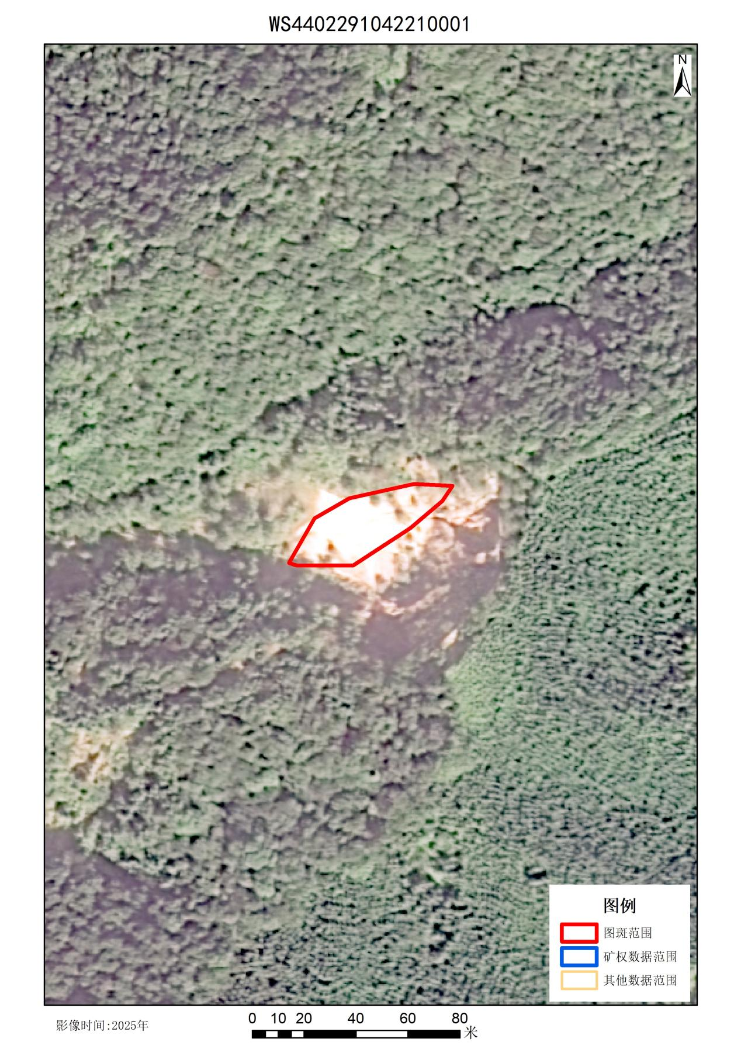

- YZ4402291042220007图斑号切图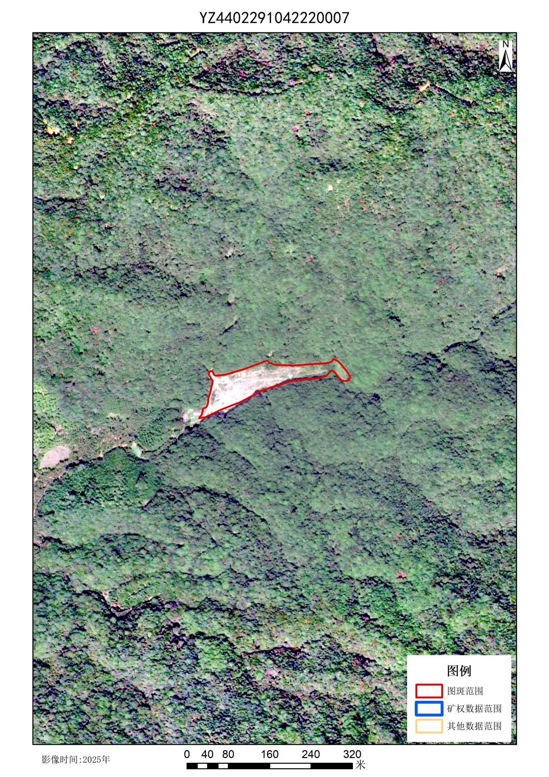

- YZ4402291042010017图斑号切图